Automating Initial Server Setup with Ubuntu 18.04
PostedApril 27, 2018 23k views Getting Started Initial Server Setup Security Automated Setups Ubuntu 18.04 Ubuntu
- 
Justin Ellingwood

Not using Automated: Bash? Choose a different version:
- CentOS 7
- Debian 9
- Debian 8
- Ubuntu 18.04
- Ubuntu 16.04
- Ubuntu 14.04
- Automated: Docker request
- Automated: Ansible request

Introduction
When you first create a new Ubuntu 18.04 server, there are a few configuration steps that you should take early on as part of the basic setup. This will increase the security and usability of your server and will give you a solid foundation for subsequent actions.
While you can complete these steps manually, sometimes it can be easier to script the processes to save time and eliminate human error. This guide explains how to use a script to automate the steps in the initial server setup guide.

What Does the Script Do?
This script is an alternative to manually running through the procedure outlined in the Ubuntu 18.04 initial server setup guide and the guide on setting up SSH keys on Ubuntu 18.04.
The following variables affect how the script is run:
- USERNAME: The name of the regular user account to create and grant sudo privileges to.
- COPY_AUTHORIZED_KEYS_FROM_ROOT: Whether to copy the SSH key assets from the root account to the new sudo account.
- OTHER_PUBLIC_KEYS_TO_ADD: An array of strings representing other public keys to add to the sudo-enabled account. This can optionally be used in addition to or instead of copying the keys from the root account.
You should update these variables as needed before running the script.
When the script runs, the following actions are performed:
- Create a regular user account with sudo privileges using the name specified by the USERNAME variable.
- Configure the initial password state for the new account:
  - If the server was configured for password authentication, the original, generated administrative password is moved from the root account to the new sudo account. The password for the root account is then locked.
  - If the server was configured for SSH key authentication, a blank password is set for the sudo account.
- The sudo user's password is marked as expired so that it must be changed upon first login.
- The authorized_keys file from the root account is copied over to the sudo user if COPY_AUTHORIZED_KEYS_FROM_ROOT is set to true.
- Any keys defined in OTHER_PUBLIC_KEYS_TO_ADD are added to the sudo user's authorized_keys file.
- Password-based SSH authentication is disabled for the root user.
- The UFW firewall is enabled with SSH connections permitted.

How To Use the Script
The script can be run in two ways: by adding it to the server's user data field during creation or by logging in as root and executing it after provisioning.

Using User Data
When creating a Droplet on DigitalOcean, you can optionally specify user data, a script to be run during the initial server provisioning to perform additional configuration.
If you are creating a Droplet from the Control Panel, you can select the User data checkbox in the Select additional options section. A text box will appear where you can paste the script:
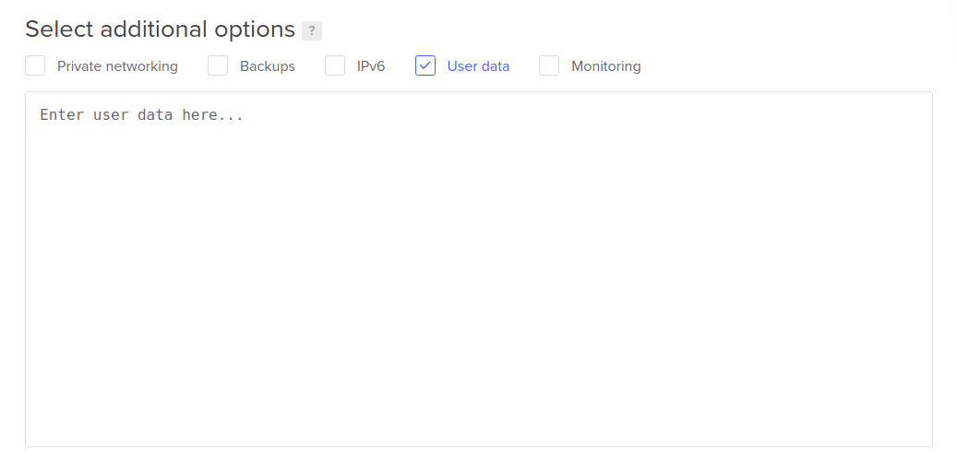
If you are creating a Droplet using the DigitalOcean API, you can pass in the script using the user_data attribute instead.
If you are creating a Droplet with the doctl command line tool, you can pass in the script using the --user-data-file option:
doctl compute droplet create ... --user-data-file /path/to/script
Regardless of the method you use to add the user data, the script will be run the first time the new server boots up. You may have to wait a few minutes for the process to complete, but afterwards, you can log into your server with your sudo-enabled user for any further configuration.
The first time you log in, you will be prompted to change your password. The server will terminate the current SSH session once you provide and confirm your new credentials. Afterwards, you can SSH back in again as normal.

Running the Script After Provisioning
If you do not want to use user data, you can also run the script manually over SSH once the server is booted up.
If you have downloaded the script to your local computer, you can pass the script directly to SSH by typing:
ssh root@servers_public_IP "bash -s" -- < /path/to/script/file
You should now be able to log in using your sudo account for any further configuration.
If you do not have the script downloaded to your local computer, start by logging into the root account on your server:
ssh root@servers_public_IP
Next, download the raw script to the server:
curl -L https://raw.githubusercontent.com/do-community/automated-setups/master/Ubuntu-18.04/initial_server_setup.sh -o /tmp/initial_setup.sh
Inspect the script to ensure that it downloaded properly and update any variables that you wish to change:
nano /tmp/initial_setup.sh
Once satisfied, run the script manually using bash:
bash /tmp/initial_setup.sh
You should be able to log in using the sudo-enabled user to complete any further configuration.

The Script Contents
You can find the initial server setup script in the automated-setups repository in the DigitalOcean Community GitHub organization. To copy or download the script contents directly, click the Raw button towards the top of the script, or click here to view the raw contents directly.
The full contents are also included here for convenience:
#!/bin/bash
set -euo pipefail

########################
### SCRIPT VARIABLES ###
########################

# Name of the user to create and grant sudo privileges
USERNAME=sammy

# Whether to copy over the root user's `authorized_keys` file to the new sudo
# user.
COPY_AUTHORIZED_KEYS_FROM_ROOT=true

# Additional public keys to add to the new sudo user
# OTHER_PUBLIC_KEYS_TO_ADD=(
# "ssh-rsa AAAAB..."
# "ssh-rsa AAAAB..."
# )
OTHER_PUBLIC_KEYS_TO_ADD=(
)

####################
### SCRIPT LOGIC ###
####################

# Add sudo user and grant privileges
useradd --create-home --shell "/bin/bash" --groups sudo "${USERNAME}"

# Check whether the root account has a real password set
encrypted_root_pw="$(grep root /etc/shadow | cut --delimiter=: --fields=2)"

if [ "${encrypted_root_pw}" != "*" ]; then
# Transfer auto-generated root password to user if present
# and lock the root account to password-based access
echo "${USERNAME}:${encrypted_root_pw}" | chpasswd --encrypted
passwd --lock root
else
# Delete invalid password for user if using keys so that a new password
# can be set without providing a previous value
passwd --delete "${USERNAME}"
fi

# Expire the sudo user's password immediately to force a change
chage --lastday 0 "${USERNAME}"

# Create SSH directory for sudo user
home_directory="$(eval echo ~${USERNAME})"
mkdir --parents "${home_directory}/.ssh"

# Copy `authorized_keys` file from root if requested
if [ "${COPY_AUTHORIZED_KEYS_FROM_ROOT}" = true ]; then
cp /root/.ssh/authorized_keys "${home_directory}/.ssh"
fi

# Add additional provided public keys
for pub_key in "${OTHER_PUBLIC_KEYS_TO_ADD[@]}"; do
echo "${pub_key}" >> "${home_directory}/.ssh/authorized_keys"
done

# Adjust SSH configuration ownership and permissions
chmod 0700 "${home_directory}/.ssh"
chmod 0600 "${home_directory}/.ssh/authorized_keys"
chown --recursive "${USERNAME}":"${USERNAME}" "${home_directory}/.ssh"

# Disable root SSH login with password
sed --in-place 's/^PermitRootLogin.*/PermitRootLogin prohibit-password/g' /etc/ssh/sshd_config
if sshd -t -q; then
systemctl restart sshd
fi

# Add exception for SSH and then enable UFW firewall
ufw allow OpenSSH
ufw --force enable

Conclusion
Automating the initial server setup can save you a bit of time and gives you a good foundation for further configuration. If there are additional steps you'd like to take, you can either log in after the script runs to continue manually, or append the steps to the end of the script to automate the process.

